Flight Delays and Cancellations

Q1: Which airlines or airports have the worst delays?
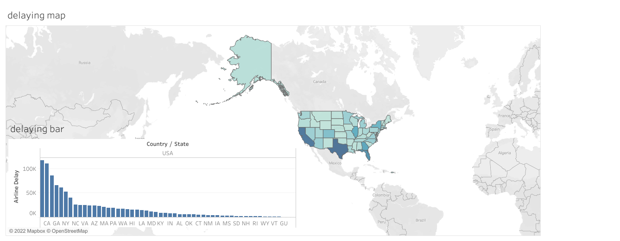
Links:
https://public.tableau.com/app/profile/fady4537/viz/Book4_16515053412990/theworestdelay

Summary:
Texas has the highest rate of airline delaying

Design:
The dashboard is explained by map and bar lines, the dark blue one the expresses the worst state

Q2: What causes delays?
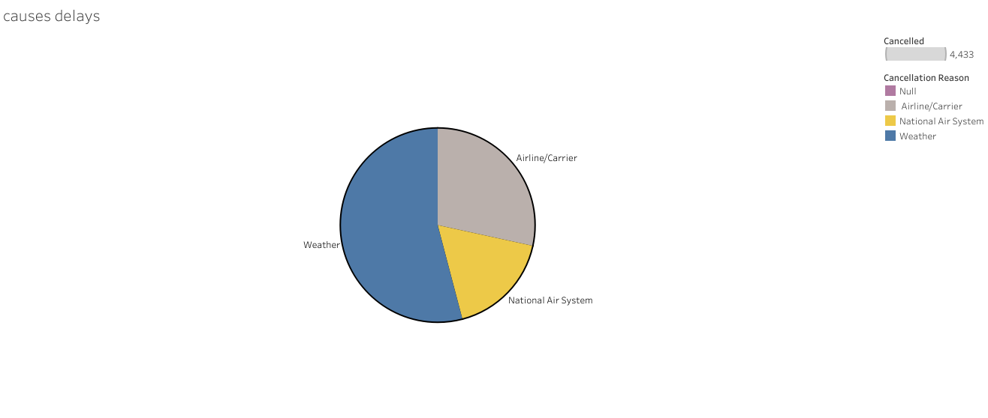

Links:
https://public.tableau.com/app/profile/fady4537/viz/Book2_16515044383380/causesdelays

Summary:
The above plot describes the worst delay airline in states

Design:
-The pie chart because it describes the most common reasons that cause the delay and the common reasons are three, we used these colors to be clear for all people including the color blind people.

Q3: Which airline arrival at a time?
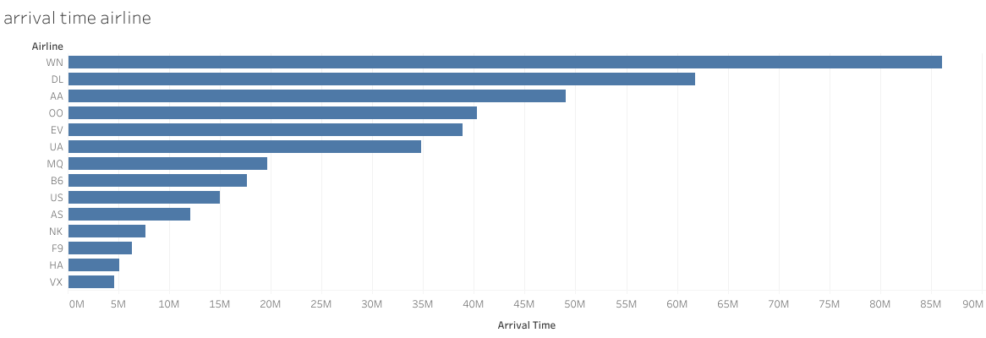

Links:
https://public.tableau.com/app/profile/fady4537/viz/Book3_16515048105230/arrivaltimeairline

Summary:
The above plot describes the best airline in the united states

Design:
The horizontal bars easily show the best airline, the longest line expresses the best airline

Resources:
https://www.kaggle.com/usdot/flight-delays/data

